Water Report 2025
Town of Seabrook, New Hampshire
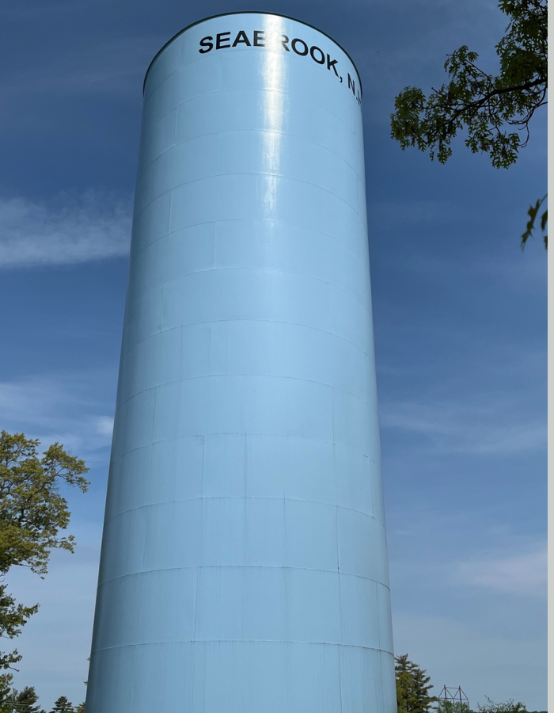
Town Manager
March 2026
Approved version prepared from year-end 2025 usage and revenue records.

Water Financial Analysis - Fiscal Year 2025
This report provides an updated five-year view of Seabrook water revenue and usage through fiscal year 2025. It follows the structure of the 2024 report and uses the attached 2025 warrant statistics workbook and 2025 water revenue report as the source records. Because no 2025 expense or debt schedule was included with the materials provided here, the financial discussion is limited to revenue and usage performance.
Executive Summary
• Total Water Fund revenue reached $3,443,151.11 in 2025, up 21.2% from 2024.
• Total pumped water was 363,078,565 gallons, down 5.4% from 2024.
• Total billed usage was 327,413,605 gallons, down 8.2% from 2024.
• Residential use remained the largest class at 53.9% of billed usage excluding lost water.
• Lost water increased to 32,664,960 gallons, or 9.0% of pumped water, compared with 6.4% in 2024.
Revenue Analysis
In 2025 the Water Fund recorded year-end revenue of $3,443,151.11. That was an increase of $601,521.11 over 2024. The attached revenue report shows that the largest line item remained Water Use Revenue, followed by Service Fee revenue. Together those two lines accounted for the bulk of receipts, while installation, inspection, interest, final-read revenue, and fire-related charges made up the balance.
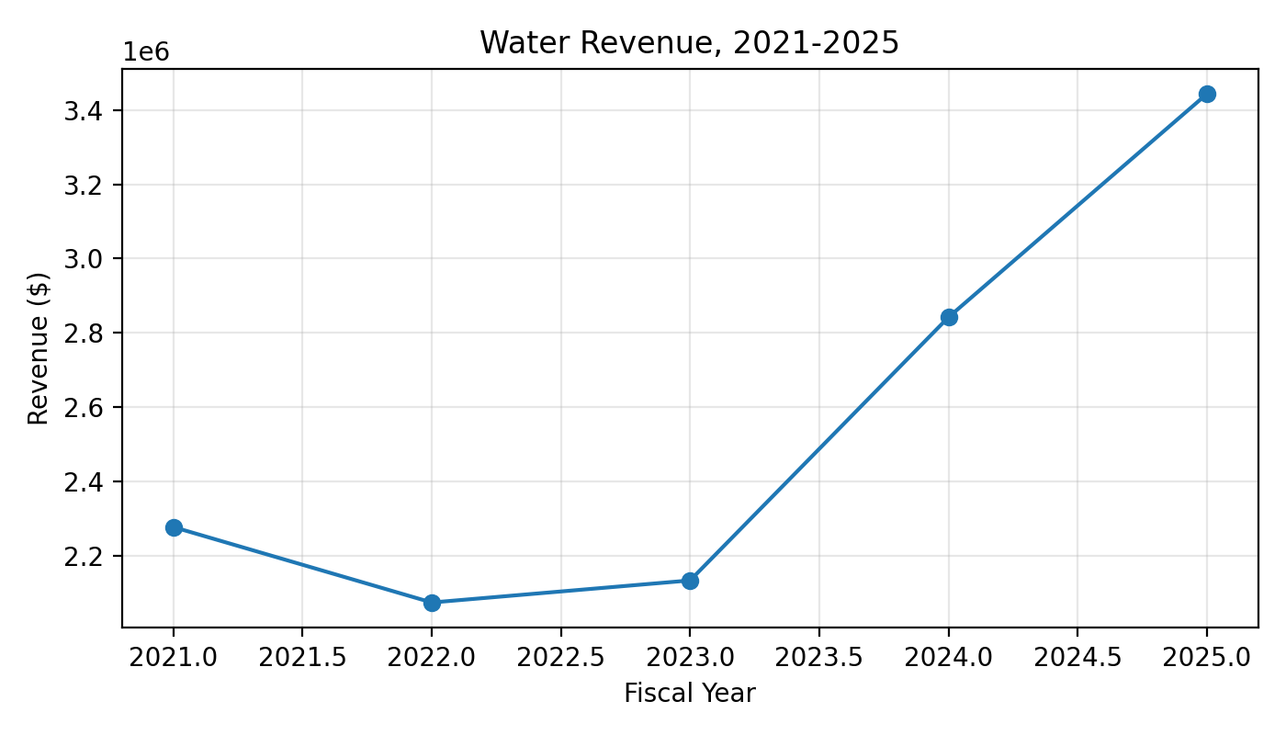
Fiscal Year | Revenue
2021 | $2,276,344
2022 | $2,073,176
2023 | $2,132,618
2024 | $2,841,630
2025 | $3,443,151.11

Usage Analysis
System pumpage fell from 383,715,000 gallons in 2024 to 363,078,565 gallons in 2025. Billed usage also declined, moving from 356,641,820 gallons to 327,413,605 gallons. The largest year-over-year decline came from Seabrook Station usage. Residential demand also decreased from the unusually strong 2024 level, while combined commercial usage was nearly flat.
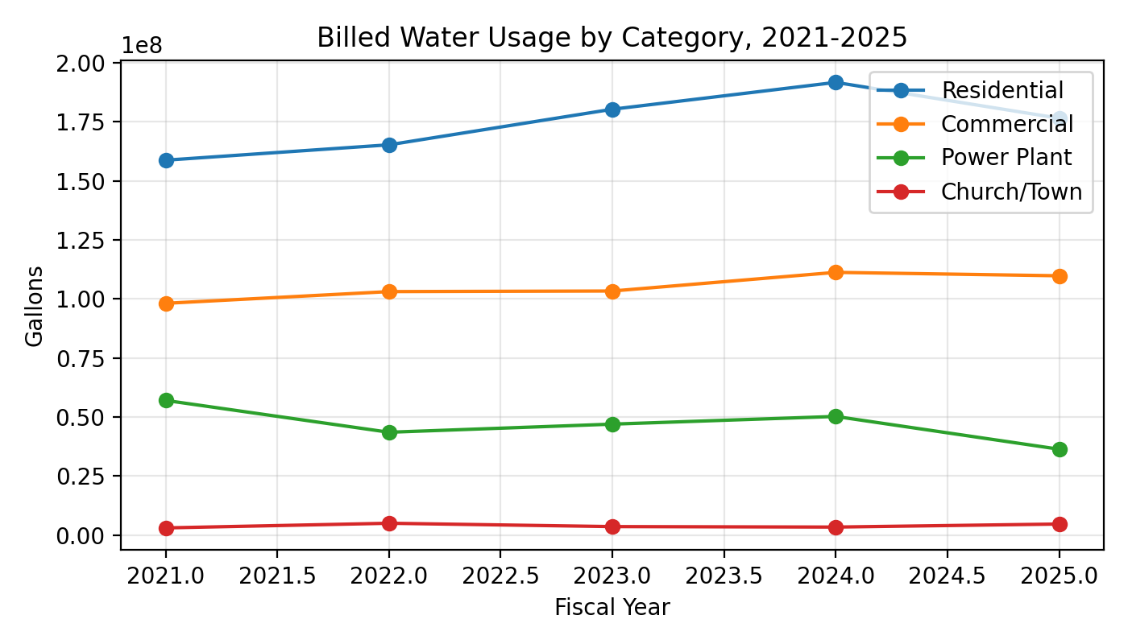
Year | Residential | Commercial | Power Plant | Church/Town | Total Billed | Lost Water
2021 | 158,808,215 | 98,159,483 | 57,025,119 | 3,014,124 | 327,922,740 | 38,024,260
2022 | 165,316,383 | 103,124,419 | 43,536,240 | 4,984,013 | 319,893,512 | 61,388,488
2023 | 180,388,481 | 103,376,848 | 46,974,948 | 3,561,965 | 334,302,242 | 41,605,758
2024 | 191,765,873 | 111,278,877 | 50,234,226 | 3,362,844 | 356,641,820 | 24,631,976
2025 | 176,580,268 | 109,831,235 | 36,349,793 | 4,652,309 | 327,413,605 | 32,664,960

2025 Usage Mix
When lost water is omitted, the 2025 mix was led by residential accounts, followed by commercial users, the power plant, and Church/Town consumption. The overall mix remained generally consistent with prior years, although the power plant share moved lower in 2025 because of reduced station demand.
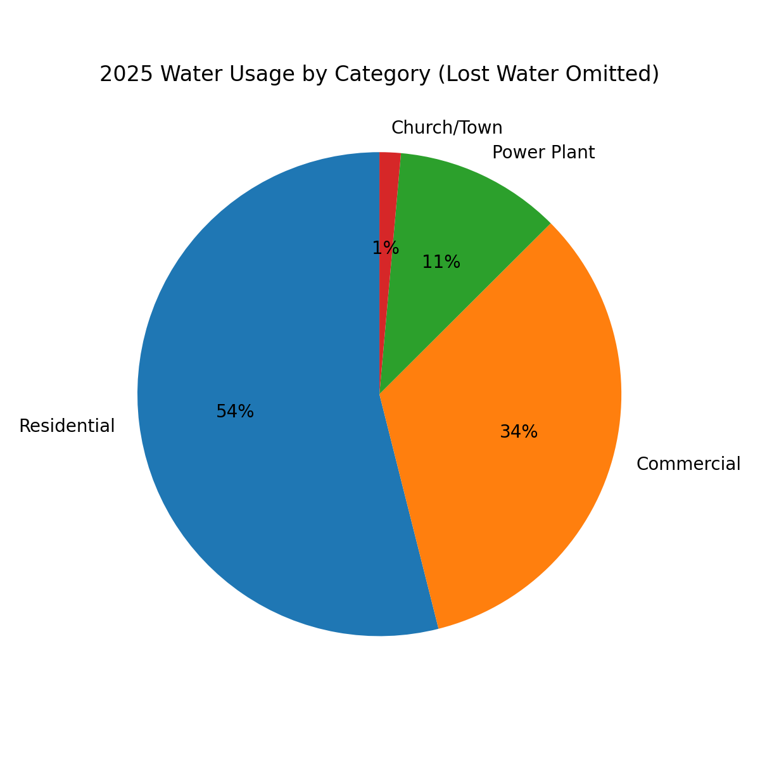
Lost Water
Lost water moved in the wrong direction in 2025. The system recorded 32,664,960 gallons of lost water, equal to 9.0% of pumped supply. In 2024 lost water was 24,631,976 gallons, or 6.4%. This should remain an operational focus in 2026.
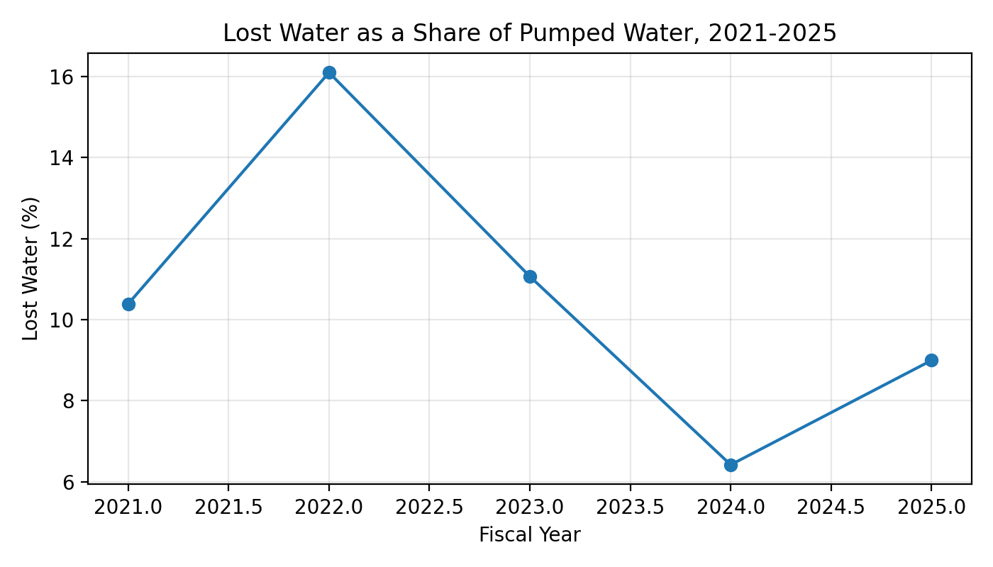
Conclusion
The 2025 record shows a stronger revenue year for the water enterprise, with total revenue rising to $3,443,151.11. At the same time, overall demand eased, especially at the power plant, and lost water increased to nearly 9.0% of pumped volume. The system therefore enters 2026 with a favorable revenue trend but with a clear need to continue managing non-revenue water and system efficiency.
Source Notes
1. Water Report 2024 Draft.pdf - used for the prior-year narrative structure and for 2021-2024 revenue history.
2. Water Usage Warrant Statistics.xlsx - used for 2021-2025 usage totals and category detail.
3. Water Revenue.pdf - used for the year-end 2025 Water Fund revenue totals and revenue-line breakdown.

